# 

**SYSTEM REQUIREMENTS SPECIFICATION**

**FOR**

**CAPITAL MARKETS AUTHORITY SYSTEM**

**November 2024**

**Project Name:**

**Version:**

**Date:**

**Prepared by:**

**Approved by:**

| Document ID | SYSTEM DESIGN-v0.1 |
| --- | --- |
| Version Number | 0.1 |
| Issue Date | 18 November, 2024 |
| Classification | Public |

# Table of Contents

# 

**Table of Contents 3**

**List of Figures 6**

**1. Introduction 6**

1.1 Background 6

1.2 Purpose 6

1.5 Scope 7

1.4 Definitions, Acronyms, and Abbreviations 7

1.5 References 7

1.6 Overview 8

**2. Overall Description 8**

2.1 System Perspective 8

2.2 System Functions 9

2.3 User Classes and Characteristics 9

2.4 Operating Environment 10

2.5 Constraints 10

2.6 Assumptions and Dependencies 11

**3. Planning for Information Gathering to Determine Systems 11**

3.1 Approach to Information Gathering 11

Interviews 11

Questionnaires 11

3.2 Information Gathering Results 12

CMA STRATEGIC PLAN 2023-2028 14

ICT POLICY 14

CUSTOMER RELATIONSHIP DIRECTIVE 14

PAYMENT PROCEDURE 14

CMA HANDBOOK 14

4. Functional Requirements 15

4.1 Functional Requirements 15

4.1.1 User Authentication 15

4.1.2 Content Management 15

4.1.3 Licensing Management 15

4.1.4 Search and Retrieval 15

4.1.5 Reporting and Continuous Reporting 15

4.2.1 Performance 15

4.2.2 Security 16

4.2.3 Usability 16

4.2.4 Scalability 16

4.3.1 User Interfaces 16

4.3.2 Hardware Interfaces 16

4.3.3 Software Interfaces 16

**4.4. Other Requirements 16**

4.4.1 Data Backup 17

4.4.2 Disaster Recovery 17

5. Use Cases and User Stories 17

5.1 Overview 17

5.2 User Classes and Characteristics 17

5.3 Sample Use Cases 17

5.3.1. Use Case: Licensing Application. 18

**5.4. Use Case Models 18**

5.5 User Stories 19

6. System Architecture 20

6.1 Overview 20

Client-side: HTML, CSS, JavaScript for user interaction. 20

Server-side: Python/Django, Node.js for handling system logic. 20

Database: MySQL for storing and retrieving data. 20

Security: Incorporating SSL, two-factor authentication, and role-based access control. 21

6.2 Architecture Diagram 21

8. Process Design 21

9. Database Design 27

9.1 Entities and Relationships 27

9.2 Entity-Relationship Diagram (ERD) 27

9.3 Normalization 27

9.4 Constraints and Security 27

10. User Interface Design 28

10.1 Overview 28

10.2 Wireframes or Screenshots 28

11. Technology Design 28

11.1 Infrastructure 28

11.2 Frameworks and Tools 28

11.3 APIs 28

12. Integration Design 28

12.1 Components 28

12.2 Integration Flow 28

12.3 Middleware 28

13. Appendices 29

# 

# 1. Introduction

## 1.1 Background

The Capital Markets Authority was created in 1989 through the Capital Markets Act Cap 485A. It is a public agency under the National Treasury and Planning of Kenya. In operation since 1990, CMA has ensured the regulation of capital markets, their promotion, and development through the issuance of licenses to market intermediaries, protection of investors, and product innovation such as bonds, REITs, and ETFs.

CMA plays an important role in mobilizing long-term capital, promoting financial literacy, and realizing Kenya's aspiration of a regional financial hub as enunciated in Vision 2030.

## 1.2 Purpose

The objective of this document is to stipulate the functional and non-functional requirements for the CMA. This document is to serve as a reference for major system stakeholders such as the developers, system analysts and the end users ensuring that the system requirements align with their intended goals. So, this document outlines the system’s objectives, features and functionalities.

The primary audience includes the CMA officials and staff, Licensed market intermediaries, Developers and IT support teams, Regulatory bodies and both institutional and retail investors.

The CMA System aims to address the need for oversight on Kenyan capital markets, investor protection, ensuring compliance with legal and regulatory frameworks and fostering investor confidence. It does this through fraud mitigation, promoting transparency and enabling long-term capital mobilization for economic growth.

**1.3 Intended Audience**

This document is intended for project stakeholders,including business analysts, developers,CMA staff and officials,IT teams,regulatory bodies and end users like stockbrokers,Investment bankers and investors.

**1.4 Intended Use**

This document is intended to be used as a blueprint for developing systems to ensure that it aligns with business requirements and objectives, compliance requirements and technical requirements and standards.

## 1.5 Scope

TheCMA System provides capabilities for supervising, licensing, ensuring regulatory compliance, handling complaints, detecting, investigating and mitigating fraud and protecting investors. The system will also abet in the initiatives to promote education and awareness of the CMA.

For users, the system simplifies access to regulatory services, ensures transparency in transactions and enables easy tracking of investments and complaints.

On the other hand, the system benefits the CMA organization by enhancing operational efficiency, fostering compliance with regulations and aids in decision making through analytics and reporting.

The capabilities of the CMA system includes licensing and approving of market intermediaries, monitoring of market activities and identifying irregularities, complaints handling, dispute resolution, providing resources for investor education and fraud detection and investigation.

The CMA system however is not meant for hosting or operating platforms for buying or selling financial securities, tracking the issuance of loans by banks to investors and handling physical unrelated administrative documents.

## 1.4 Definitions, Acronyms, and Abbreviations

1. CMA - Capital Markets Authority.
2. API - Application Programming Interface.
3. SRS - Software Requirements Specification.
4. CDS - Central Depository System.
5. CMFIU - Capital Markets Fraud Investigation Unit.
6. ISO/IEC - International Organization for Standardization/ International Electrotechnical Commission.
7. CBK - Central Bank of Kenya.
8. KRA - Kenya Revenue Authority.
9. SQuaRE - Systems and Software Quality Requirements and Evaluation.

## 1.5 References

1. CMA Handbook 2021– Comprehensive guidelines and operational framework of the Capital Markets Authority.
2. Capital Markets Act Cap 485A – The legal foundation for the establishment and operations of the CMA.
3. ISO/IEC 25010:2011 – Systems and Software Quality Requirements and Evaluation (SQuaRE).
4. Regulatory Sandbox Policy Guidance Note 2019 – CMA document for testing innovative solutions.
5. CMA Website: [www.cma.or.ke](https://www.cma.or.ke)

## 1.6 Overview

This SRS specifies the features, functional requirements and non-functional requirements of the Capital Markets Authority of Kenya System.

The First five sections of the document outline the purpose, scope and relevant terminology of the system, the goals, perspective, functions, user characteristics, operating environment and constraints of the system. They specify the functional and non-functional requirements of the system and the use cases and user stories.

The subsequent sections specify the system’s architecture, the use case models, process design, database design, user interface, technology design and the integration design of the system.

# 2. Overall Description

## 2.1 System Perspective

The CMA system operates within the regulatory and financial landscape of Kenya’s capital markets which is highly regulated. The financial ecosystem adheres to Kenyan legal and regulatory frameworks and aligns to global financial standards. The system interfaces with various stakeholders and other systems to fulfill its regulatory, oversight and developmental functions.

In collaboration with the CMA System, the Central Depository System (CDS)facilitates the electronic management of financial securities, holdings and transactions.

The CMA system connects with Market Intermediary Systems used by brokers, investment banks and fund managers for licensing and compliance reporting.

External Fraud Monitoring Systems Interfaces with the Capital Markets Fraud Investigation Unit (CMS FIU) systems for fraud mitigation.

Public access to investor education, submission of complaints and updates to regulations are made possible by interfacing the CMAsystem with the Public Portals.

Collaboration between the CMA system and Government Systems such as Kenya Revenue Authority (KRA) and the Central Bank of Kenya (CBK) ensures compliance to tax regulations and financial integration.

### **2.2 System Functions**

**Licensing and compliance**: Process applications for licenses by market intermediaries and allow for checking the license application approval status. Monitor and report on compliance with regulations.

**Investor Protection**: To manage the investor compensation fund and facilitate investor education and awareness on market risks.

**Market Surveillance and Monitoring**: To detect irregular trading patterns and real-time oversight of the transactions involving financial securities such as stocks in order to prevent fraud.

**Complaints and Dispute Resolution**: This entails handling complaints issued by investors and facilitating dispute resolution. It also includes supporting anonymous reporting of conflict incidents and whistleblowing.

**Regulatory Reporting and Analytics:** This involves generating reports for decision making and formulating policies. Conducting risk assessment and market trends using analytics.

**Fraud Detection and Investigation:** Through integration with the Capital Markets Fraud Investigation Unit, fraud cases can be managed and prosecuted.

**Public Access and Awareness:** Utilize public portals to provide regulatory updates, educational materials and investor tools.

### **2.3 User Classes and Characteristics**

The CMA system is designed to serve a diverse group of users, each with unique needs:

**CMA Staff and Regulators:** These professionals work in the organization and fulfill duties such as the issuance licenses, compliance monitoring, surveillance, and crafting policies. Their needs that enable them to fulfill these duties include robust reporting tools, secure data management and fraud detection tools.

**Market Intermediaries:** Brokers, fund managers, investment banks and credit rating agencies are users that are considered to be market intermediaries each playing a specific role. Their system needs to include seamless licensing processes, and compliance reporting.

**Investors:** They include retail and institutional investors. These investors require access to investment tools, educational resources and complaint mechanisms.

**The General Public:** This user group includes potential investors, students and researchers. They need information on the capital markets, regulatory updates and public resources from the system.

**Third Party Systems:** This includes government bodies such as Kenya Revenue Authority (KRA) and international organizations. These third party bodies need data sharing, compliance integration and reporting from the CMA system.

### **2.4 Operating Environment**

The system will operate under the following conditions:

**Hardware Requirements:** The system needs servers with high-availability for data storage and processing. Secure end-user devices such as laptops and desktops are also required for the staff.

**Software Requirements:** The CMA system needs a web based application interface, database systems such as oracle for data management. Analytical tools such as Microsoft Power BI for reporting and visualization.

**Network Requirements:** Secure internet connection to facilitate real-time data exchange is needed along with Virtual Private Network (VPN) and firewalls to enable secure remote access.

**Environmental Conditions:** Critical functionalities require 24/7 uptime and disaster recovery systems will be implemented for backing up data and reinforcing the system’s fault tolerance.

**2.5 Stakeholders and Their Roles**

| **Stakeholder** | **Role** |
| --- | --- |
| Stockbrokers | Facilitate trading activities by connecting investors to the stock market. |
| Fund Managers | Manage investment portfolios for clients and ensure compliance with CMA regulations. |
| Investment Bankers | Provide financial services such as underwriting and advising on capital raising while adhering to CMA guidelines. |
| Investors | Participate in the capital markets, relying on CMA for a fair and transparent environment. |
| IT and Technical Team | Manage and maintain the CMA Online Portal and other technological systems. |
| Legal and Compliance Team | Ensure that all operations comply with legal and regulatory standards. |
| Finance Department | Oversee financial operations, budgeting, and revenue management for the CMA. |

### **2.6 Constraints**

**Regulatory Compliance:** The CMA system needs to adhere to the Capital Markets Act and any related laws put forth by the Kenyan government. It also has to be in compliance with international financial standards such as International Financial Reporting Standards (IFRS).

1. **Budgetary Limitations**:
   * Resource allocation for system development and maintenance may be constrained.
2. **Technological Constraints**:
   * Dependence on legacy systems used by some intermediaries.
   * Need for high system reliability and uptime to prevent disruptions.
3. **Data Security and Privacy**:
   * Compliance with data protection laws and secure handling of sensitive financial data.

### **2.7Assumptions and Dependencies**

The system assumes that there is consistent exchange of data between the CMA and the users and compliance with regulatory requirements and guidelines.

# 3. Planning for Information Gathering to Determine Systems

## 3.1 Approach to Information Gathering

This task aimed at creating a comprehensive and detailed plan on how to gather information from users in order to elicit system requirements for the Capital Market Authority. Collecting information is crucial to ensure that the final product aligns with the needs of both users and stakeholders

The Approaches included the following:

### **Interviews**

**Purpose:** To gaugethe challenges faced by the user in accessing and using the application and continuous reporting portal need to be assessed.

**Target Audience:** stockbrokers, dealers, investment advisers, fund managers, investment banks, derivatives dealers, central depository, authorized securities dealer, CMA staff, IT managers, investors and authorized depository licenses.

### **Questionnaires**

**Purpose:**To gather relevant information,insight and feedback on the online portal services, common issues and necessary features.

**Target Audience:** Investors i.e. the public, banks, fund managers, trusts, stockbrokers and financial institutions.

## 3.2 Information Gathering Results

| **METHOD** | **PURPOSE** | **TARGET AUDIENCE** | | **INFORMATION EXPECTED** | **USE OF INFORMATION IN DETERMINING SYSTEM REQUIREMENTS** | **REMARKS** |
| --- | --- | --- | --- | --- | --- | --- |
| INTERVIEWS | To gauge the specific challenges faced by the user in accessing and performance of the application and continuous reporting portal. | stockbrokers, dealers, investment advisers, fund managers, investment banks, derivatives dealers, central depository, authorized securities dealer, CMA staff, IT managers, investors and authorized depository licenses. | | Focus on the difficulties such as access to online application, ease or difficulty in license application, additional functionality, approval and reporting obligations. | Identify common challenges, technical issues, and user needs for better system communication and functionality | Specifies the needs of the users and helps tailor the system and improve efficiency. |
| QUESTIONNAIRES | To gather relevant information, insight and feedback from online investors in the markets, dealers, stockbrokers. | Investors i.e. the public, banks, fund managers, trusts, stockbrokers and financial institutions. | | Feedback on the online portal services, common issues and necessary features. | Direct the system designers to enhance usability functionality and improve user and customer satisfaction. | Highlights the challenges faced by the users. |
| SAMPLING | To gather the information produced by the system and the portal about the licences, licence application, approvals report obligations, system transaction logs and performance reports | Online portal and the public systems available. | | Duration taken by the system to approve the application confirm the necessary documents, examples of system outputs, data structures and form content. | Sample the usage, the application process, ease of the system and the traffic during peak hours so that the system designers can configure the optimal conditions for maximum efficiency and gauge how the data is currently managed. | Highlights the system challenges and may single out the places of improvement. |
| DOCUMENT ANALYSIS | Review and ensure Online portal complies with the official Capital Markets Authority (CMA), regulatory, policy, process, procedures and operational goals and documents. | REGULATORY | [CAPITAL MARKETS ACT](http://pckamunya.co.ke/wp-content/uploads/2018/07/Capital-Markets-Act.pdf) | Legal policies, strategic goals to be met, operational policies, process and procedural policies to meet the required goals. | Helps ensure the system aligns with regulations, addresses legal obligations, and tracks progress according to the CMA’s strategic plan. | May help the system comply with the regulations, ensures goals and policies are met to improve user experience. |
| STRATEGIC | [CMA STRATEGIC PLAN 2023-2028](https://www.cmarcp.or.ke/images/Docs/2018/CapitalMarkets.pdf) |
| POLICY | [ICT POLICY](https://www.ca.go.ke/sites/default/files/CA/Statutes%20and%20Regulations/National-ICT-Policy-Guidelines-2020.pdf) |
| PROCESSES | [CUSTOMER RELATIONSHIP DIRECTIVE](https://www.cma.or.ke/investor-protection/) |
| PROCEDURES | [PAYMENT PROCEDURE](https://www.cma.or.ke/public-announcement/) |
| OPERATIONS | [CMA HANDBOOK](https://www.cma.or.ke/wp-content/uploads/2023/05/CMA-Handbook-2021.pdf) |

## 

## 4. Functional Requirements

## 4.1 Functional Requirements

### **4.1.1 User Authentication**

FR1: The system shall provide secure login functionality for all user classes.

FR2: The system shall support password reset via email.

FR3: The system shall support two-factor authentication for added security.

### **4.1.2 Content Management**

FR4: Users shall be able to create new content items (articles, images, videos).

FR5: Users shall be able to edit existing content items.

FR6: The system shall provide a workflow for content approval before publication.

### **4.1.3 Licensing Management**

FR7: Licensing applicants shall submit their applications via the system.

FR8: Licensing authorities shall review applications and either approve or reject them.

FR9: The system shall provide status updates to applicants about their application progress.

### **4.1.4 Search and Retrieval**

FR10: The system shall provide a search function to find content based on keywords, tags, and metadata.

### **4.1.5 Reporting and Continuous Reporting**

FR11: The system shall support real-time reporting and allow CMA staff to generate reports on licensing and content activities.

**4.2 Non-Functional Requirements**

### **4.2.1 Performance**

NFR1: The system shall support up to 1000 concurrent users.

NFR2: Page load times shall not exceed 3 seconds under normal conditions.

### **4.2.2 Security**

NFR3: All data transmissions shall be encrypted using HTTPS.

NFR4: User passwords shall be stored using secure hashing algorithms.

NFR5: Role-based access control (RBAC) shall be implemented to ensure appropriate access to system features.

### **4.2.3 Usability**

NFR6: The user interface shall be responsive and compatible with major web browsers.

NFR7: The system shall provide inline help and tooltips for major functions.

### **4.2.4 Scalability**

NFR8: The system architecture shall support future expansion to accommodate additional content types and users.

**4.3. System Interfaces**

## 4.3.1 User Interfaces

The system shall provide a web-based interface accessible via standard web browsers (e.g., Chrome, Firefox, Safari, Edge).

## 4.3.2 Hardware Interfaces

There are not many hardware requirements since it is a web based application.

## 4.3.3 Software Interfaces

The system shall interface with a relational database management system (e.g., MySQL) for data storage.

The system shall interact with a web server (e.g., Apache, Nginx) for hosting.

Integration with a Business Rules Management System (BRMS) will allow the automation of business rules and decisions, such as license approval.

# 4.4. Other Requirements

## 4.4.1 Data Backup

The system shall perform daily backups of all content and user data, ensuring the security and integrity of the stored information.

## 4.4.2 Disaster Recovery

The system shall have a disaster recovery plan with a recovery time objective (RTO) of 4 hours.

**4.4.5 Fraud Detection Algorithms**

This is to ensure there is enhanced security.

**4.5.6 Reporting Dashboard**

This is specifically for CMA officials to monitor compliance and complaints.

## 5. Use Cases and User Stories

## 5.1 Overview

The task was aimed to develop use case stories that show how the users will interact with the system. These stories described step-by-step actions users take to accomplish specific goals.

## 5.2 User Classes and Characteristics

Content Creators: Staff responsible for creating and editing content.

Editors: Staff responsible for reviewing and approving content.

Administrators: Staff responsible for managing user accounts and system settings.

Licensing Applicants: Users submitting applications for licenses (stockbrokers, dealers, investment advisers, etc.).

Licensing Authorities: Staff reviewing and approving license applications.

Viewers: Public users consuming the published content.

## 5.3 Sample Use Cases

### **5.3.1. Use Case: Licensing Application.**

**Actors**: Applicant, Licensing Authority

**Preconditions**: Applicant has submitted a complete license application.

**Main Flow**:

Applicant submits a license application.

The licensing authority reviews the application.

The decision is made to either approve or reject the application.

**Alternative Flows**:

If the application is incomplete, the system prompts the applicant to provide additional details.

**Postconditions**: License is either granted or the applicant is notified of the rejection.

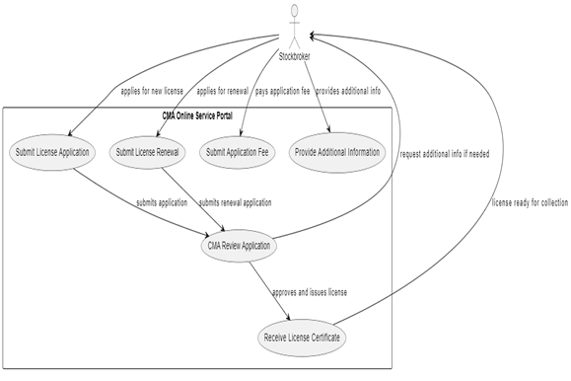

# *Figure 1: Use Case*

# 5.4. Use Case Models

This task is aimed to develop use case diagrams that visualize user interactions with the system, showcasing various actors and their corresponding actions.

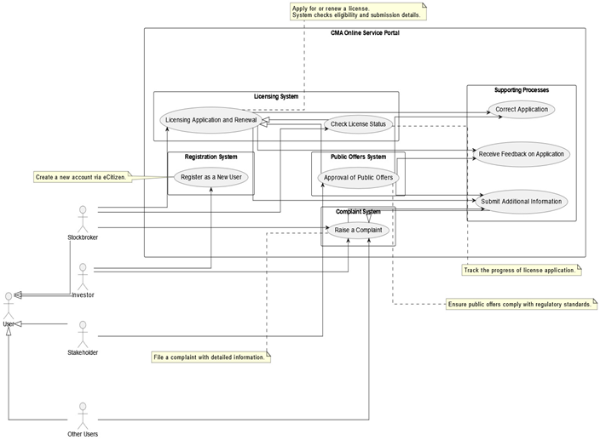

*Figure 2: Use Case Diagram*

### **5.5 User Stories**

**Example User Story:**Register as a new user

**Actor: investor**

**Purpose:** to create a new account on the CMA Online services portal

**Preconditions:**

must not have an account with the online service portal.

must be a legally registered entity under the Capital Markets Authority in Kenya.

The person carrying out the business of a stockbroker must be authorized to hold a valid license issued by the Authority.

**Main Flow:**

The investor navigates to the registration page of the Online portal.

The investor is directed to the Ecitizen platform.

The investor is given an option to choose whether he is a resident, diplomat, foreigner or a refugee.

investor is asked for personal details to confirm his status and whether he or she has an account with the platform.

The investor fills out and submits the application form.

The investor is officially registered after confirmation through the email.

**Alternative Flow:**

If the email already exists in the system, an error message is displayed prompting the investor to use a different email address.

**Postconditions:**

The investor receives a confirmation email confirming that he is a new user in the system and is given a unique identification.

## 6. System Architecture

### **6.1 Overview**

### Client-side: HTML, CSS, JavaScript for user interaction.

### Server-side: Python/Django, Node.js for handling system logic.

### Database: MySQL for storing and retrieving data.

### Security: Incorporating SSL, two-factor authentication, and role-based access control.

### 

### **6.2 Architecture Diagram**

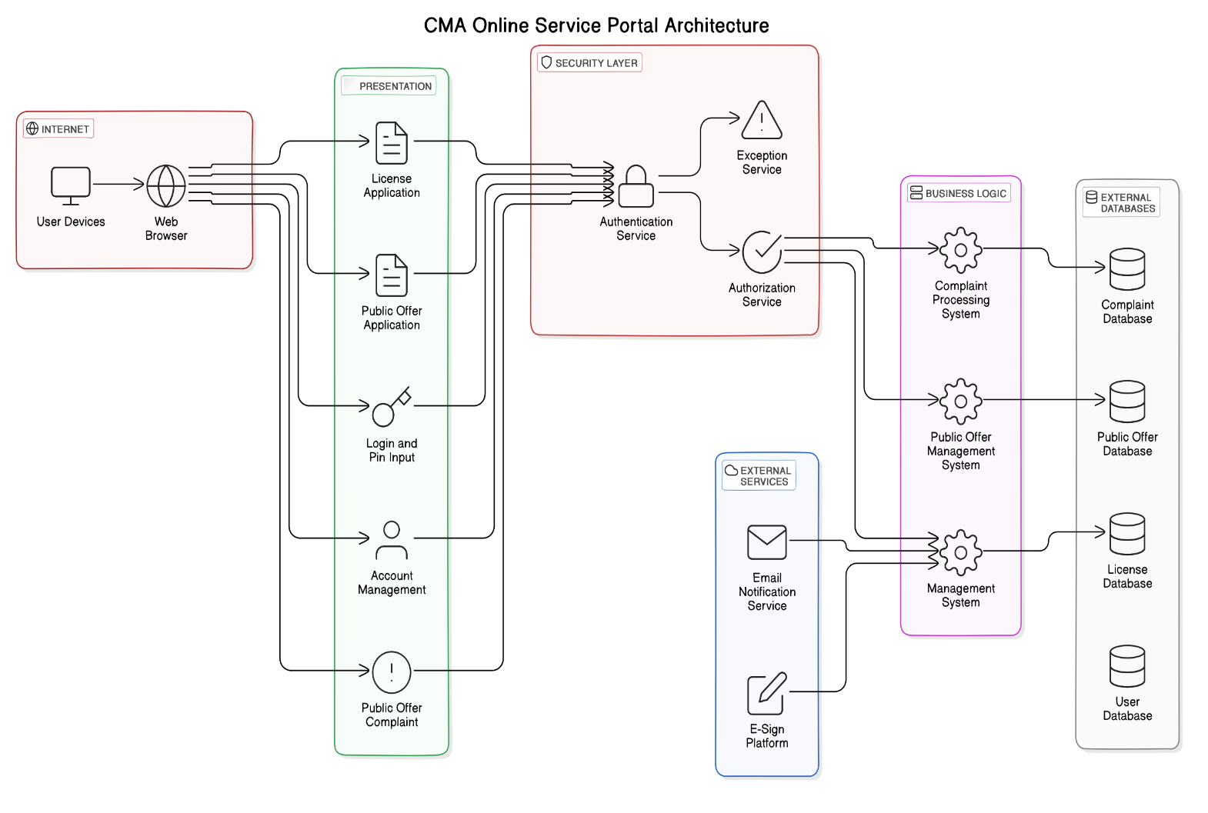

## *Figure 3:* Architecture Diagram

## 

## 

## 8. Process Design

**8.1.1 Context Diagram:**

A Context Diagram (Level 0) represents the most comprehensive level of a data flow diagram, illustrating the entire system as a singular process that engages with external entities. It offers an overarching perspective of the system, emphasizing its boundaries and the manner in which it communicates information with external entities.

In the Context of the CMA online portal, it provides an overall view of the interaction between the online system and the external entities such as Stockbrokers, Investment banker and Investor.

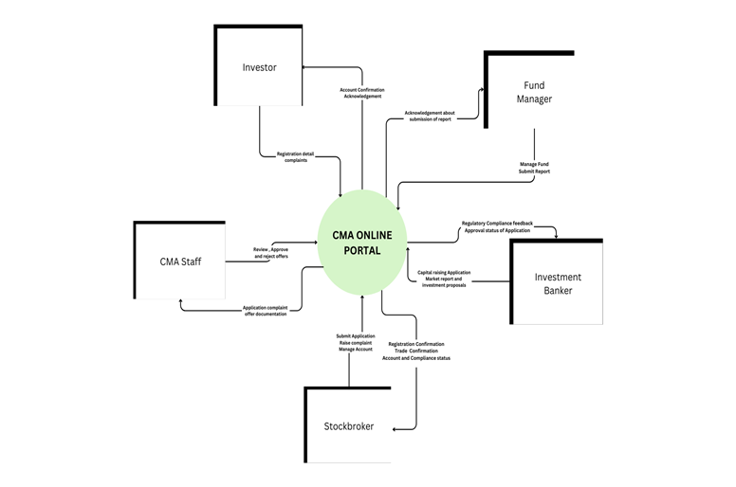

*Figure 4: context Diagram*

**8.1.2 Top-Level Data Flow Diagram**

A Top-Level Data Flow Diagram (Level 1 DFD) disaggregates the singular process depicted in the Context Diagram into multiple sub-processes. This diagram provides a more detailed representation of the system's internal processes and illustrates the specific data flow among these processes, external entities, and data repositories.

In the context of CMA online portal, it breaks down each process and captures the inner workings. For example, how the licensing process by Stockbrokers works.

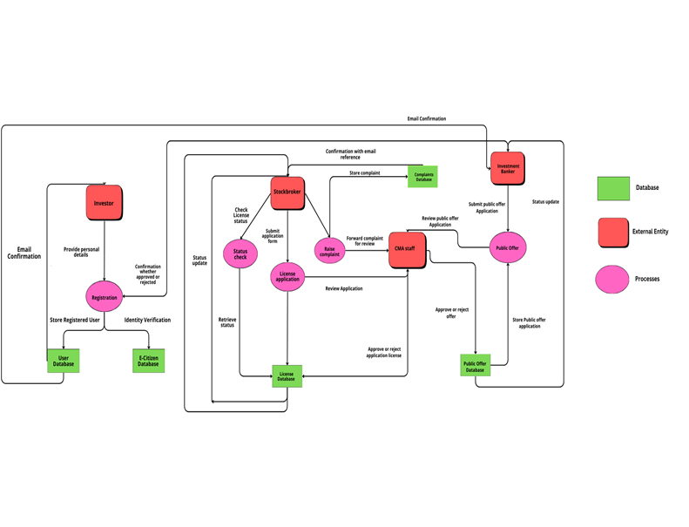

*Figure 5:Top-level data flow Diagram*

**8.1.3 Exploding DFDs:  
Exploded Data Flow Diagram For Public Offer Application Process**

An Exploded Diagram shows more detail of the process and breaks down how a certain process interacts with different components and entities.

The diagram below shows lower level details for the process of applying for a Public Offer which include Mergers and Listings and acquisitions.

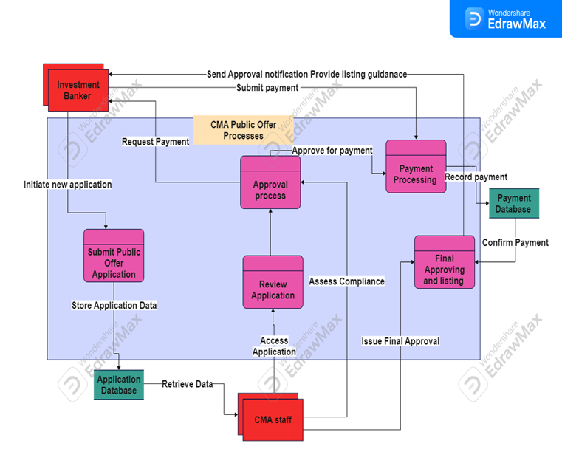

*Figure 6: Exploding DFDs Diagram*

**8.1.4 Process Specifications:**   
**Application for Public Offer on the CMA portal Process Specification**

**Process ID: P02**

**Process Name: Application for Public Offer**

**Brief Description:**

This process involves the comprehensive review of a public offer application by CMA staff, including the assessment of compliance with regulations and standards. The Investment Banker initiates the process by submitting the application, which is then stored in the Application Database. The system reviews, approves, and processes the payment, issuing a final approval and listing.

**Input Data Flows:**

1.Public Offer Application Form (submitted by Investment Banker)

2. Access Application (from Application Database).

3. Payment Request (sent to Investment Banker).

4.Submit Payment (from Investment Banker).

5.Compliance Check Data (from Review Application process)

**Output Data Flows:**

1.Assess Compliance (to Approval process).

2. Approve for Payment (to Payment Processing).

3.Record Payment (to Payment Database).

4.Approved Application (to Final Approving and Listing).

5.Rejection Notification (if compliance fails).

**Type of Process:**

Online.

**Uses Prewritten Code:**

No.

**Process Logic Description:**

**Receive Application**:

Investment Banker submits the application via the system.

System verifies if all necessary fields are completed.

If the application is incomplete, an error message is displayed to the Investment Banker.

**Store Application**:

Upon verification, the system stores the application in the **Application Database**.

A confirmation message is sent to the Investment Banker notifying that the application has been received.

**Initiate Compliance Review**:

The stored application triggers the **Review Application** process.

**CMA staff** access the data and perform compliance checks.

**Approval for Payment**:

* If the application passes compliance, the system sends an approval notification to the Investment Banker.
* The system then requests payment for the public offer process.

**Payment Processing**:

Once payment is received, the payment system stores the payment information in the **Payment Database**.

The system confirms the payment and initiates the **Final Approving and Listing** process.

**Issue Final Approval**:

After payment, the system issues a final approval for the public offer and updates the public records.

**Error Handling**:

If there is a failure at any stage (e.g., non-compliance, payment failure), the system logs the error and notifies the Investment Banker with further instructions.

**Decision tree**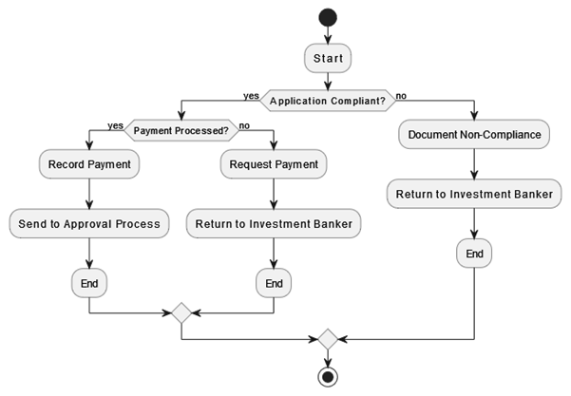

*Figure 7: Decision tree Diagram*

## 9. Database Design

### **9.1 Entities and Relationships Stockbroker**

### **Attributes:** StockbrokerID (PK), Name, Email, Phone, Address

### **Fund Manager**

### **Attributes:** FundManagerID (PK), Name, Email, Phone, Address

### **Investment Banker**

### **Attributes**: InvestmentBankerID (PK), Name, Email, Phone, Address

### **Investor**

### **Attributes**: InvestorID (PK), Name, Email, Phone, Address

### **Application**

### **Attributes**: ApplicationID (PK), ParticipantID (FK), Type, SubmissionDate, Status

### **Payment**

### **Attributes**: PaymentID (PK), ApplicationID (FK), Amount, PaymentDate, Status

### **Complaint**

### **Attributes**: ComplaintID (PK), ParticipantID (FK), Description, SubmissionDate, Status

### **Public Offer**

### **Attributes**: OfferID (PK), CompanyName, OfferType, SubmissionDate, ApprovalStatus

### **Relationships:**

### Each participant type (Stockbroker, Fund Manager, etc.) is linked to applications via ParticipantID.

### Applications are associated with payments through ApplicationID.

### Complaints are tied to participants through ParticipantID.

### Public offers are submitted by companies and linked via OfferID.

### 

### **9.2 Entity-Relationship Diagram (ERD)**

*Figure 8:Database Design Diagram* 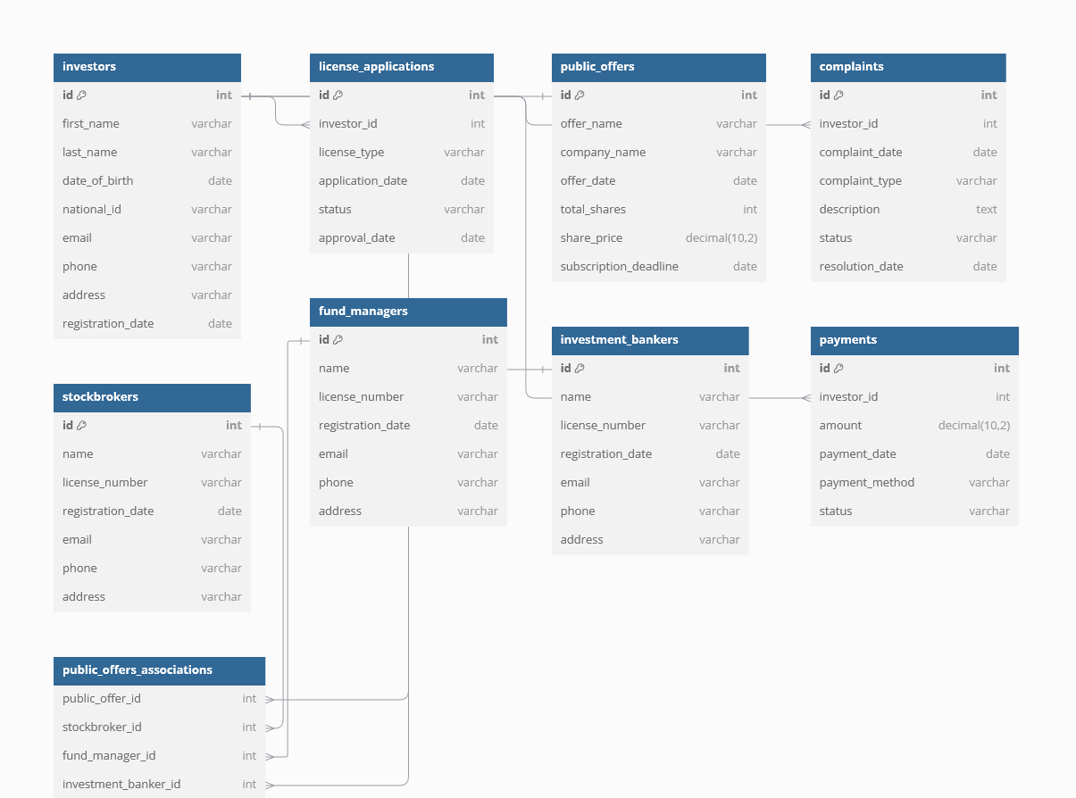

### **9.3 Normalization**

**First Normal Form (1NF):**

* All tables have unique primary keys.
* Each attribute contains atomic values.
* No repeating groups or arrays.

**Second Normal Form (2NF):**

* Removed partial dependencies.
* All non-key attributes are fully dependent on the primary key.
* Example: The Application table stores Type and SubmissionDate attributes solely related to ApplicationID.

**Third Normal Form (3NF):**

* Eliminated transitive dependencies.
* Non-key attributes are dependent only on the primary key.
* Example: Complaint table ensures Status depends directly on ComplaintID.

### **9.4 Constraints and Security**

**Constraints:**

1. **Primary Keys (PK):**

Uniquely identify each record in their respective tables (e.g., StockbrokerID, ApplicationID).

1. **Foreign Keys (FK):**

Maintain referential integrity by linking related records across tables (e.g., ParticipantID in Application references IDs in participant tables).

1. **Data Integrity Rules:**

Prevent invalid data entries through constraints such as NOT NULL, UNIQUE, and validation checks.

**Security Measures:**

1. **Encryption:**

Sensitive data (e.g., personal information, payment details) is encrypted using advanced cryptographic methods (AES, RSA).

1. **Access Control:**

Role-based access ensures only authorized users can view or modify specific data.

1. **Audit Trails:**

All transactions are logged to track changes and access for compliance and monitoring.

## 10. User Interface Design

### **10.1 Overview**

**Design Philosophy:**

The design philosophy for the CMA Online Service Portal emphasizes the following principles:

1. **Responsive Design:**
   * Ensures optimal viewing and interaction across various devices (desktop, tablet, and mobile).
   * Adapts layout and interface components dynamically based on screen size and resolution.
2. **Accessibility:**
   * Includes features such as screen reader compatibility, keyboard navigation, and sufficient color contrast.
3. **User-Centric Approach:**
   * Focuses on simplifying workflows for diverse user roles, such as stockbrokers and investors.
   * Streamlined navigation and clear visual hierarchy prioritize frequently used features.
4. **Consistency:**
   * Maintains uniform design patterns, including button styles, fonts, and color schemes, for a cohesive user experience.

### **10.2 Wireframes or Screenshots**

**10.2.1 Dashboard**

The dashboard layout is designed to present this data in a quick, easy-to-scan format with the most relevant information understandable at a glance.

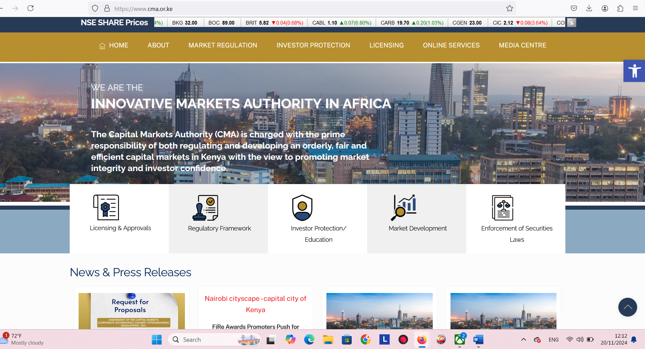

***10.2.2 Landing Page***

The landing page is designed to provide visitors with a seamless and focused experience that guides them towards a specific action:

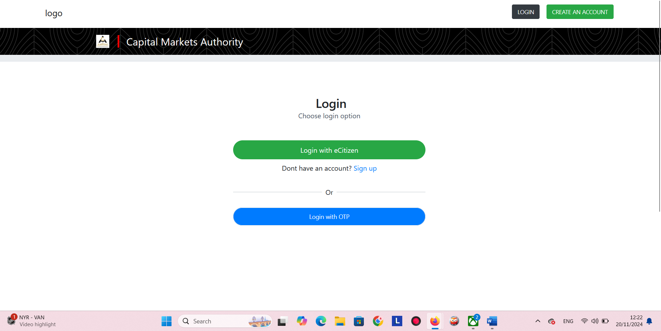

**Input Design:** Licensing Request Form

* Fields: Applicant details, license type, and submission date.
* Features: Validation, dropdowns for license types, and dynamic help text.

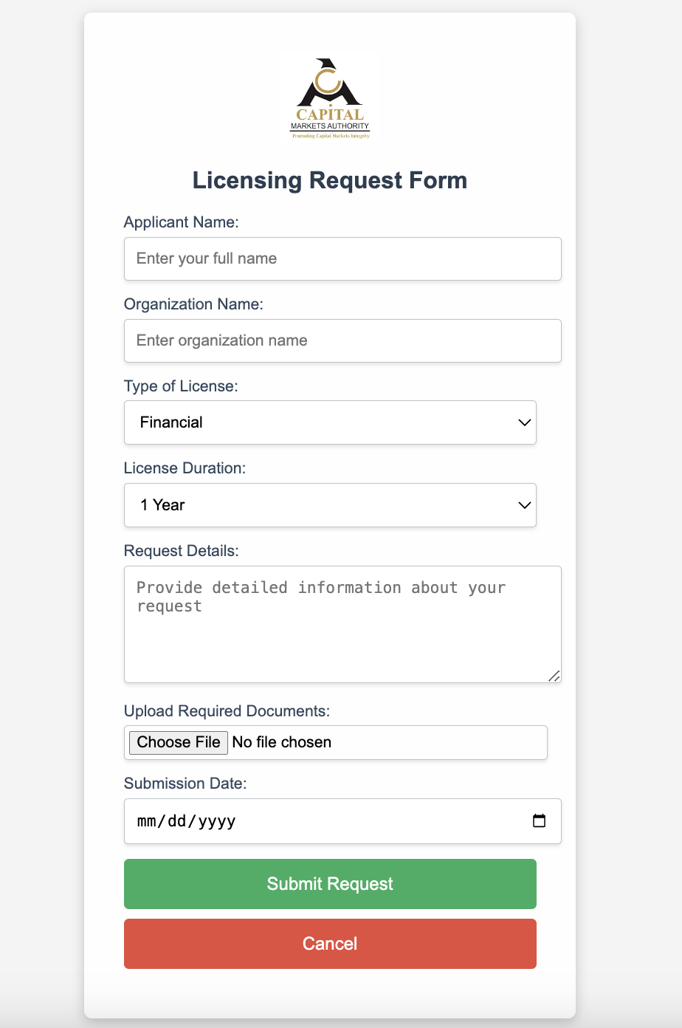

*Figure 9 : Input Form*

**Output Design:** Invoice for Payment of Public Offer Application

* Details: Application ID, payment breakdown, total amount, and due date.
* Features: Printable format and download options.

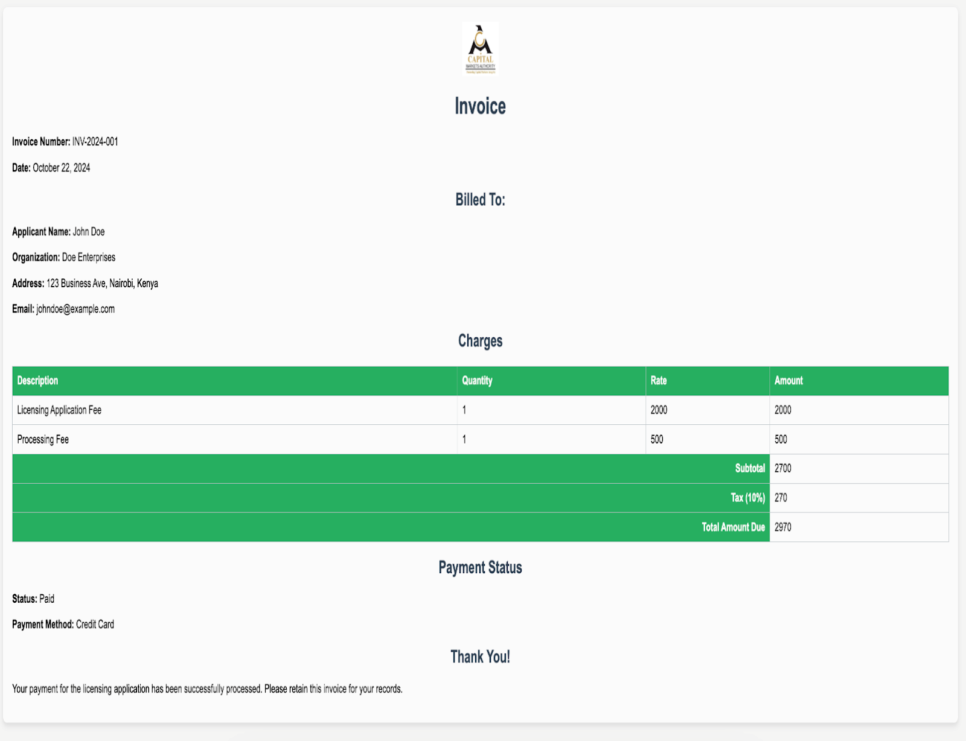

*Figure 10 : Output Report*

## 11. Technology Design

### **11.1 Infrastructure**

**Cloud Infrastructure:**The system leverages Microsoft Azure for its server and storage needs, ensuring scalability and reliability for data management.

**Network and Security:**Utilizes Virtual Private Cloud (VPC) and Virtual Private Network (VPN) configurations to provide secure access to CMA data.

**Traffic Management:**A load balancer is in place to distribute high-traffic user requests efficiently, ensuring system availability and performance.

**Operating Systems:**

Linux for backend servers to support robust and secure processing.

Windows for staff systems to ensure compatibility with administrative tools.

**Database Management:** PostgreSQL or Oracle databases are employed for compliant and efficient data storage.

### **11.2 Frameworks and Tools**

**Development Tools:**

**CI/CD Tools:** Automate software updates and deployments.

**Containerization:** Docker is used to package applications, ensuring consistency across environments.

**Monitoring Tools:** Continuously check system health and performance.

**Libraries:**

**Frontend Libraries:** React or Angular for developing dynamic user interfaces.

**Backend Libraries:** Provide server-side functionality to handle complex logic.

**Security Libraries:** Tools like JWT are used for secure user authentication and data protection.

### **11.3 APIs**

**External APIs:**Integrates with external services like Mpesa for payments and eCitizen for government data access, enhancing functionality and user experience.

**Internal APIs:**Facilitates data exchange between different modules within the CMA system, ensuring seamless operation.

**API Gateway:**Manages API traffic, providing a secure and controlled environment for external and internal integrations

.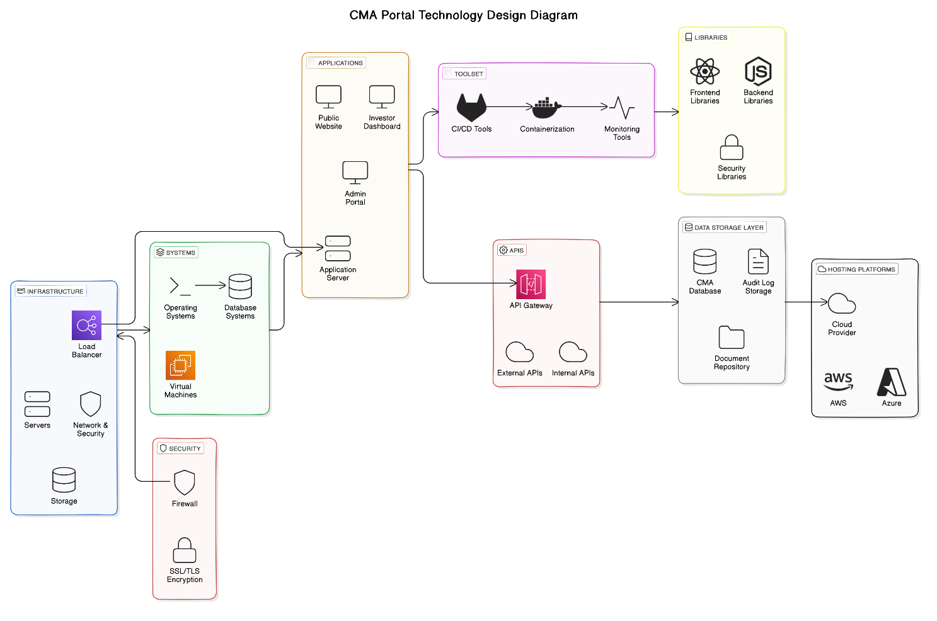

*Figure 11 : Technology Design Diagram*

## 12. Integration Design

### **12.1 Components**

The key system components for integration in the Capital Market Authority Portal include:

1. **Applications**: Public Website, Investor Dashboard, and Admin Portal, enabling user access.
2. **Application Server**: Manages all incoming user requests.
3. **Centralized Database**: Handles all data storage and retrieval.
4. **Network Security Tools**: Includes Load Balancer, Firewall, VPC, and VPN for secure and encrypted connections.
5. **Secure API Gateway**: Facilitates interaction with external systems such as Mpesa, banking systems, KRA, and eCitizen.
6. **Core Services**: Supports user authentication, payment processing, ID verification, and data synchronization.

### **12.2 Integration Flow**

The data and processes flow between components as follows:

1. **User Interaction**: Users access the system via applications (Public Website, Investor Dashboard, or Admin Portal).
2. **Request Handling**: The Application Server processes user requests.
3. **Data Flow**: Data such as user information, transactions, verifications, and payments flow securely through different layers.
4. **External Service Communication**: The Secure API Gateway manages interactions with external systems (e.g., Mpesa and KRA) for real-time transactions and verifications.
5. **Event Triggering**: Specific user actions (like login or transactions) trigger relevant services, ensuring accurate and timely responses.

### **12.3 Middleware**

Middleware tools and their roles in the CMA Portal system:

1. **Secure API Gateway**: Acts as middleware to handle secure interactions between the portal and external systems.
2. **Event Trigger System**: Facilitates real-time responses by connecting user actions to appropriate services.
3. **Data Synchronization Services**: Ensures consistency and reliability across all system components and external integrations.

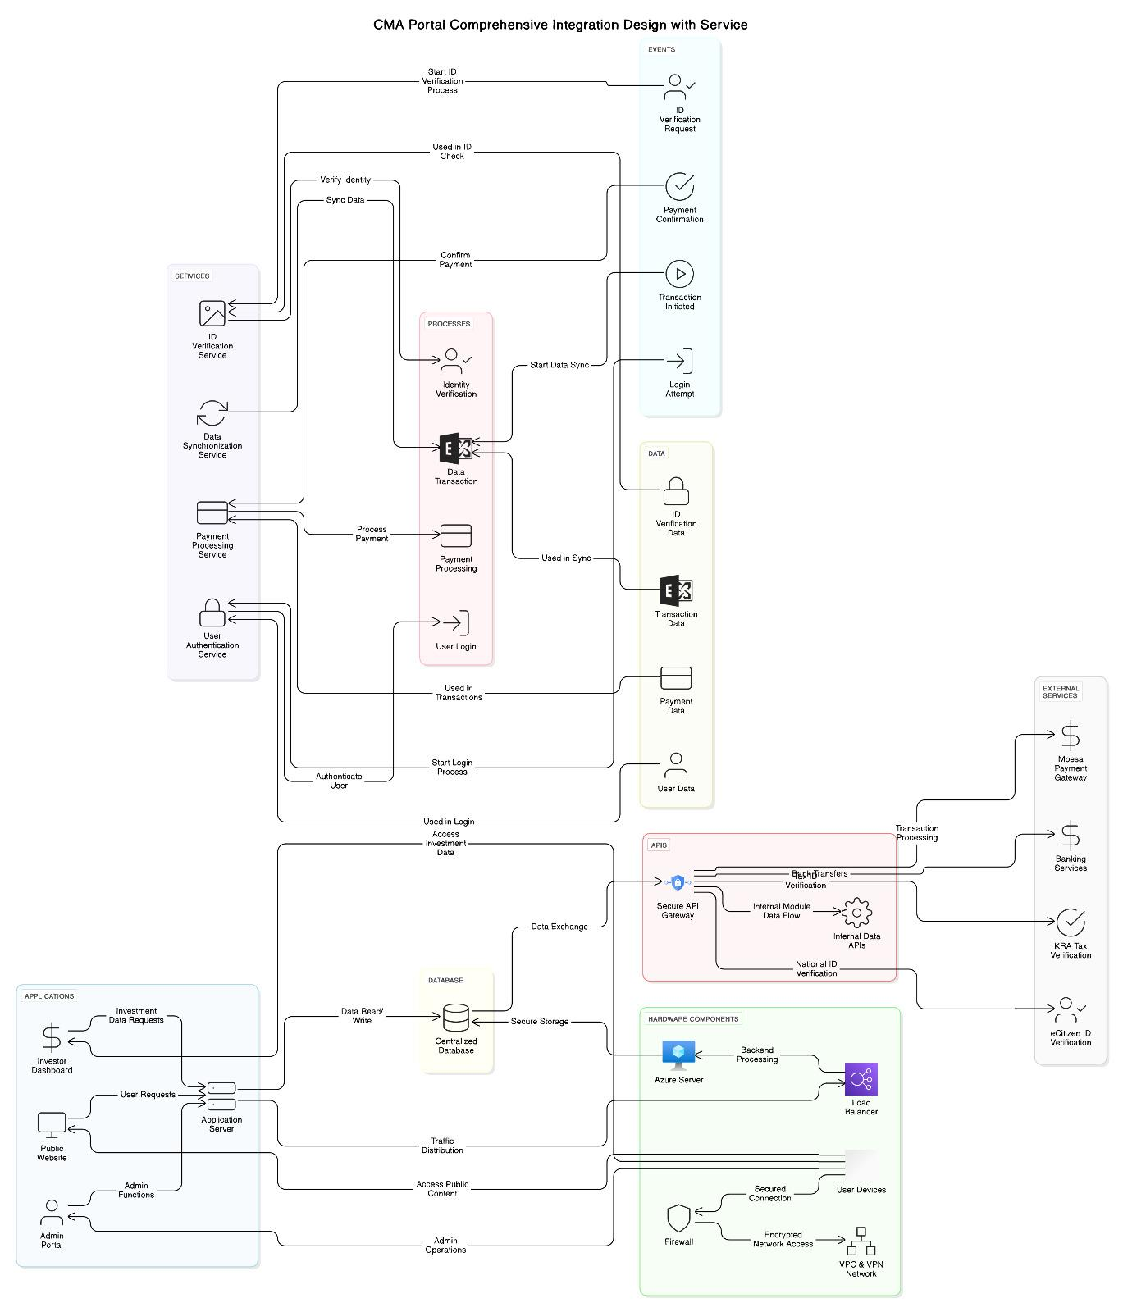

*Figure 12 : Integration Design Diagram*

## 13. Appendices

### **END USER MANUAL OF THE CAPITAL MARKETS AUTHORITY (CMA) SYSTEM**

#### **Introduction**

The CMA System is designed to streamline the licensing, compliance, and reporting processes for market participants in Kenya's capital markets. This user manual will guide you through the essential steps for a seamless experience.

### **Getting Started**

#### **Accessing the System**

* Ensure you have your login credentials.
* Visit the CMA portal at cma.ecitizen.go.ke

#### **Submitting Your Application**

* Navigate to the **"Submit Application"** section.
* Fill in the required information and upload necessary documents, such as identification.

### **Application Processing**

#### **Application Review**

* CMA staff will review your application for completeness and accuracy.

#### **Integration with External Systems**

* The system may connect with external agencies such as KRA or Mpesa to verify your documents and process payments.

### **Decision and Notification**

#### **Staff Decision**

* CMA staff will use the system's generated review report to make decisions on licensing or compliance.

#### **Notification**

* You will receive an automated notification via email or the portal about the status of your application.

### **Post-Decision**

#### **License Issuance (if approved)**

* If approved, your official license or compliance certificate will be available for download through the system.

#### **Additional Information**

* **Incomplete Application**: The system will guide you on the necessary steps to provide additional details or documents.
* **Application Denial**: If denied, the system will clearly state the reasons, allowing you to address deficiencies and reapply.

### **Support and Feedback**

#### **Need Help?**

* For assistance, refer to the FAQs on the portal or contact our support team at support@cma.or.ke.

#### **Feedback**

* We value your feedback. Let us know how we can enhance your experience through the feedback form available on the portal.

Thank you for using the CMA System. We are committed to making the licensing and compliance process efficient, transparent, and user-friendly for all participants in Kenya's capital markets.